  - PURPOSE

  - The purpose of this user guide is to provide guidance in implementing a Dangerous Goods Competency-Based Training and Assessment Programme for personnel involved in the transport of Cargo, Mail, Passengers and baggage by air.

  - This Advisory Circular is applicable to all operators, training organizations and other entities dealing with Air cargo and Dangerous Goods in Tanzania and is to be used in conjunction with the ICAO Technical Instructions for the Safe Transport of Dangerous Goods and applicable Tanzania Civil Aviation Regulations (TCARs) as amended. IATA Dangerous Goods Regulations may also be used.

REFERENCE

  - The Civil Aviation (Transport of Dangerous Goods by air) Regulations, 2024

  - The Civil Aviation (Air Operator Certification and Administration) Regulations, 2017 as amended

  - The Civil Aviation (Operation of Aircraft-Commercial Air Transport) Regulations, 2024

  - The Civil Aviation (Operation of Aircraft-Helicopter Operations) Regulations, 2024

  - The Civil Aviation (Operation of Aircraft-General Aviation) Regulations, 2024

  - The Civil Aviation (Safety Management) Regulations, 2018

  - ICAO Doc 9284, Technical Instructions for the Safe Transport of Dangerous Goods by Air

  - ICAO Supplement to the Technical Instructions for the Safe Transport of Dangerous Goods by Air

  - ICAO Doc 10147, Guidance on a Competency-Based Approach to Dangerous Goods Training and Assessment

  - ICAO Doc 9868, Procedures for Air Navigation Services Training Chapter 2

  - ICAO Doc 9481 Emergency Response Guidance for Aircraft Incidents Involving Dangerous Goods

  - ICAO Doc 10002 Cabin Crew Safety Training Manual

  - IATA Dangerous Goods Regulations as amended

  - IATA DGR Training Guidance as amended
- DEFINITION OF TERMS AND ABBREVIATIONS

3.1 For purposes of this Advisory Circular the following terms and abbreviations shall have the following meanings:

- Adapted competency model means a group of competencies with their associated description and performance criteria adapted from an ICAO competency framework that an organization uses to develop competency-based training and assessment for a given role.

- Attitude means a persisting internal mental state or disposition that can be learned and that influences an individual’s choice of personal action toward an object, person or event. Attitudes have affective components, cognitive aspects and behavioral consequences. To demonstrate the “right” attitude, a learner needs to know how to “be” in a given context.

(c) Competency means a dimension of human performance that is used to reliably predict successful performance on the job. A competency is manifested and observed through behaviors that mobilize the relevant knowledge, skills and attitudes to carry out activities or tasks under specified conditions.

- Competency Standard means level of performance that is defined as acceptable when assessing whether or not competency has been achieved.

(e) Competency-based training and assessment means training and assessments that are characterized by performance orientation, emphasis on standard performance and their measurement, and the development of training to the specified activities or tasks under specified conditions.

- Conditions means anything that may qualify a specific environment in which performance will be demonstrated

- ICAO competency Framework means a competency framework, developed by ICAO, is a selected group of competencies for a given aviation discipline. Each competency has an associated description and observable behaviors

- Knowledge means knowledge is specific information required to enable a learner to develop and apply the skills and attitudes to recall facts, identify concepts, apply rules or principles, solve problems, and think creatively in the context of work.

- Observable behavior means a single role-related behavior that can be observed and may or may not be measurable.

- Performance criteria means statements used to assess whether the required levels of performance have been achieved for a competency. A performance criterion consists of an observable behavior, condition(s) and a competency standard.

- Skill means an ability to perform an activity or action. It is often divided into three types: motor, cognitive and metacognitive skills.

(l) Abbreviations
ATO Aviation Training Organizations
CARs Civil Aviation Regulations
CBTA Competency-Based Training and Assessment
DG Dangerous Goods
SMS Safety Management System
SSP State Safety Programme

GUIDANCE AND PROCEDURES

  - Introduction

    - The ICAO Dangerous Goods Panel introduced the Competency Based Training and Assessments approach in 2017 and has allowed states to align their Dangerous Goods training regimes before the end of 31 December 2022.

    - As a transitional arrangement, training and assessment completed and certificates that are issued before 1 January 2023 with a validity period beyond 1 January 2023 will continue to be valid until they expire. The changes require employers defined in applicability to amend their training programs accordingly. The training programs shall be submitted to TCAA for approval.

  - Establishment of Dangerous Goods Training Programmes

All operators, training organizations and other entities involved in transport of cargo, mail, passengers and their baggage by air must establish a competency-based training and assessment approach program.

    - A training program must include elements such as design methodology, assessment, initial and recurrent training, instructor qualifications and competencies, training records and evaluation of the effectiveness of training.

The employer must establish and maintain a Dangerous Goods training program for personnel performing any function described in this advisory circular.

    - The employer who does not have the resources to train their personnel in-house may utilize services of third-party training providers. However, the employer is still responsible for determining the training needs for employees, ensuring the employees acquire the necessary competent level to perform their functions and evaluating how well the program and/or course provided by third providers can address the needs before selecting a training provider.

The employer may outsource knowledge training, but the “on the job” (OJT) competency assessment or simulation must be conducted in-house utilizing the knowledge from training, standard operating procedures, and all other regulatory procedures applicable to the operator’s environment pertinent to carrying out a particular function the trainee is being assessed on.

    - All operators must establish a Dangerous Goods training program regardless of whether or not they are approved to transport Dangerous Goods as cargo by air.

Objective of Dangerous Goods Training

    - The main goal of competency-based training and assessment is to produce a competent workforce by providing focused training. It does so by identifying key competencies that need to be achieved, determining the most effective way of achieving them and establishing valid and reliable assessment tools to evaluate their achievement.

    - A competency is defined as a dimension of human performance that is used to reliably predict successful performance on the job. It is manifested and observed through behavior that mobilize the relevant knowledge, skills and attitudes to carry out activities or tasks under specified conditions.

    - A competency framework with associated performance criteria provides a means of assessing whether trainees achieve the desired performance. A competency framework and associated task list for dangerous goods personnel are described in ICAO Doc 10147, current IATA DGR and is also included in this guidance material for easy reference.

    - A critical feature of competency-based training is assessment to ensure training is efficient and effective in developing the skills, knowledge and attitudes required to perform the function competently.

Benefits of Competency-Based Training and Assessment for the Safe Transport of Dangerous Goods by Air

    - The main benefit of a competency-based approach to training and assessment is its potential to encourage and enable personnel to reach their highest level of capability while ensuring a basic level of competence as a minimum standard. It does this by:
      - targeting specific training needs;
      - supporting continuous learning and performance improvement;
      - gearing towards learning rather than simply passing a test;
      - ensuring the integration of the knowledge, skills and attitudes needed to perform effectively; and
      - establishing sufficient, well-trained, and competent instructors.

Relationship Between Competency-Based Training and Assessment and Safety Management

    - Safety is ICAO’s guiding and most fundamental strategic objective. ICAO Annex 19 to the Convention on International Civil Aviation — Safety Management contains Standards and Recommended Practices (SARPs) intended to assist States in managing aviation safety risks.

    - The foundation of safety management is the implementation of a State Safety Programme (SSP) by States and safety management systems (SMS) by service providers. An operator’s SMS addresses the aviation activities that are related to the safe operation of the aircraft in accordance with Annex 6. These aviation activities include the carriage of dangerous goods. Other entities in the dangerous goods transport chain should be encouraged to implement a similar safety system.

    - Implementing SMS requires that all personnel understand the safety philosophy and embrace a disciplined and standardized approach for SMS. Personnel need to know their roles and responsibilities with respect to dangerous goods and have the requisite competencies to perform their functions within the SMS. To ensure that personnel have the knowledge, skills and abilities to support SMS, training activities should follow the competency-based approach.

Function-Specific Training

    - The Technical Instructions state that personnel must be trained commensurate with the functions for which they are responsible. These responsibilities are determined by the specific function’s personnel perform and not by their job titles.

    - Concentrating on functions and responsibilities rather than a job title or description ensures that a person is competent to perform the function in compliance with the Technical Instructions.

    - For example, entities such as ground handling companies and freight forwarders may need personnel to perform some functions that are typically performed by shippers or operators. Ground handling and freight forwarder personnel would need to be trained to perform these functions competently regardless of their job title.

    - In smaller operations, personnel may perform many functions such as accepting dangerous goods and loading and securing dangerous goods on board an aircraft. They would need to be trained to perform all of these functions competently. In larger operations, personnel may perform only a small number of functions. They would only need to be trained to perform those specific functions competently.

    - The depth of training each person receives should be appropriate to the functions performed. This could range from a familiarization level to an expert level for certain personnel.

    - The employer must ensure that personnel are trained and found competent to perform any function for which they are responsible prior to performing any of these functions. This must be achieved through training and assessment commensurate with the functions for which they are responsible. Such training must be based on the competency-based training and assessment approach to dangerous goods training (CBTA) and must include:
      - General awareness/familiarization training — Personnel must be trained to be familiar with the general provisions;
      - Function-specific training — Personnel must be trained to perform competently any function for which they are responsible; and
      - Safety training — Personnel must be trained on how to recognize the hazards presented by dangerous goods, on the safe handling of dangerous goods, and on emergency response procedures.

    - The employer must ensure that personnel who have received training but who are assigned to new responsibilities/functions must be assessed to determine their competence in respect of their new function. If competency is not demonstrated, appropriate additional training must be provided.

Recurrent Training and Assessment

    - As detailed in the Civil Aviation (Air Operator Certification and Administration) Regulations, personnel must receive recurrent training and assessment within 24 months of previous training and assessment to ensure that competency has been maintained.

    - However, if recurrent training and assessment is completed within the final three months of validity of the previous training and assessment, the period of validity extends from the month on which the recurrent training and assessment was completed until twenty-four (24) months from the expiry month of that previous training and assessment.

Training and Assessment Records

    - The employer must maintain a record of training and assessment for personnel as stated in the Civil Aviation Regulations

    - The record of training and assessment must include:
      - The individual’s name;
      - The month of completion of the most recent training and assessment;
      - A description, copy or reference to training and assessment materials used to meet the training and assessment requirements;
      - The name and address of the organization providing the training and assessment; and
      - Evidence which shows that the personnel have been assessed as competent.

    - Training and assessment records must be retained by the employer for a minimum period as prescribed in the Civil Aviation Regulations and Technical Instructions for the safe Transport of Dangerous Goods by Air.

Approval of Training Programmes Using The CBTA Approach

    - The applicable Technical Instructions requires operators involved in the transport of Dangerous Goods to train their employees using the competency-based training and assessment approach prior the mandated date 31 December 2022.

    - Employers shall ensure that the Dangerous Goods training programs are approved by the TCAA in accordance with the Civil Aviation (Air Operator Certification and Administration) Regulations.

    - The Training programs may be contained in operations manuals, training manuals or stand-alone dangerous goods procedures for operators and all other entities (forwarders, handlers, shippers etc.) as applicable.

    - An application for approval or amendment of a dangerous goods training program in the operator’s manual and other entities shall be submitted to the Authority for approval.

    - An application for approval or amendment of a dangerous goods training program in the Approved Training Organization’s training and procedures manual shall be submitted to the Authority for approval.

    - Only training providers approved to train Dangerous Goods may be contracted to assist with the CBTA implementation.

Application for Approval

    - An application to grant an approval for establishment of a Dangerous Goods Training Program must be made to the Authority as per instructions above.

    - The application shall be accompanied by the Dangerous Goods Training programme or equivalent and shall include, in addition to any other relevant information specified in TCARs, the following details:
      - Name of the training organization;
      - Functions of personnel to be trained as per the guiding templates.
      - Particulars of the type of training e.g. class-room/virtual/CBT/Online facilities and training aids;
      - Description of the training materials to be used to meet the training requirements.
      - Names, qualifications and experience of the instructors;
      - Maximum number of participants to be enrolled in a class;
      - Where third party services are to be used, such must be stated including the extent of involvement.

Documentation Evaluation

    - The Dangerous Goods Training programme shall be in accordance with the Civil Aviation (Air Operator Certification and Administration) Regulations and as a minimum shall contain the following chapters, namely:
      - Introduction
      - Functions of personnel to be trained.
      - Qualifications and experience of the instructors
      - Course Objective
      - Course Structure/Methodology
      - Course Contents
      - Course Schedule/Training plan
      - Lesson Plans
      - Summative and formative assessments
      - Sample Examination Papers
      - Course Evaluation forms
      - Specimen Certificate
      - Maintenance of Training Records
      - Instructor Qualification and maintenance
      - Assessor Qualification and maintenance

    - A system shall be developed to review and revise the training programme so as to incorporate the amendments, as and when issued, to the provisions of Annex 18 to the Chicago Convention, the Technical Instructions (Doc. 9284), the TCARs, and any other related document. A copy of the programme so revised shall be submitted to the TCAA immediately for concurrence/approval.

Training Material

    - The training material shall contain as a minimum the following:
      - Trainee support material such as a:
        - learner manual
        - exercises
        - case studies
        - videos
        - checklists (where required)

      - Assessment shall contain as a minimum the following:
        - Case studies;
        - Simulations;
        - Self-test;
        - Quizzes; and
        - formal exams

    - The Delivery Method
Training material shall indicate the delivery methods chosen for various sections of training. Example

TASK /MODULE | LEVEL OF PROFICIENCY | TYPE OF TRAINING DELIVERY METHOD
Understanding the basics of dangerous goods | Introductory | E-learning
Processing/accepting cargo | Intermediate | Classroom – instructor training

Competency-Based Training and Assessment

    - Roles and Responsibilities in a Competency-Based Approach

The Employer(s) (The Operators, the training organizations and other entities)
        - shall develop a training program which includes elements such as design methodology, initial and recurrent training, assessment, instructor qualifications and competencies, training records and evaluation of its effectiveness.
        - need to determine the purpose and objective of the competency-based training program based on the functions for which their personnel are responsible. Employers should ensure that training is designed and developed to establish clear links among the competencies to be achieved, the learning objectives, assessment methods, and course materials.
        - must study the target population (trainees) with a view to identifying the knowledge, skills and attitudes that they already possess, to collect information on preferred learning styles, and on the social and linguistic environments of prospective trainees. The target population may be a mixture of experienced and newly recruited personnel, groups differing in age, etc. All these components could have an impact on the design of the training.
        - shall submit the training program to TCAA for approval before commencing training.
        - some employers may utilize third parties for assistance. This approach may be the most suitable for employers who do not have the resources to train their personnel in house. While utilizing third parties may be cost effective, the deciding factor in selecting a third party should be whether or not the training needs are being addressed, and not costs alone. The potential for third parties to cater to the training needs of multiple employers and not address all required competencies of each specific employee needs to be taken into account. Employers remain responsible for ensuring their personnel are competent to perform their functions prior to performing them even if certain aspects of the training program have been delegated to third parties.
        - should liaise directly with the Authority to ensure that the fundamental requirements are considered prior to proceeding with the development of competency-based training.

Instructor
      - In competency-based training, the instructor facilitates the trainee’s progression towards the achievement of competencies. Instructors also support continuous improvement by collecting information about the effectiveness of the training materials.
      - Only TCAA approved Dangerous Goods instructors can participate in the CBTA programs and assessment
      - CBTA Instructional Techniques
      - Instructors shall be trained on initial and recurrent on the advanced dangerous goods proficiency level.
      - Instructors shall have knowledge of the TCARS relating to dangerous goods
      - Instructors shall at minimum have 3 years working knowledge and experience in dangerous goods, safety operations or experience in cargo operations, including performing the function they are training on
      - Instructors shall undergo a practical activity in the operation at least every 2 years in the functional area/s they are training on or have undertaken CBTA training/workshop recognized by the Authority.

    - Requirements to issue instructor approval shall be as defined below.

 | (a) | The competency based practical assessment shall evaluate both the instructional capability of candidates by requiring them to assume the role of instructor by delivering a full course of dangerous goods as per the course of Dangerous Goods and also evaluate the knowledge delivery.  The practical evaluation shall be conducted at the candidates preferred venue. The following
requirements shall be met before practical evaluation is conducted:
- The approval shall be conducted by a TCAA Inspector (s).
- The candidate must have been evaluated internally on the subject to be approved by a TCAA inspector.
- The evaluation shall be in accordance with the, “Observe, Interact and lead approach.
 | (c) | Observe: a new instructor shall attend as the observer;
 | (d)  (e) | Interact: a new instructor shall prepare a course or part of the course and co-facilitate with the certified instructor; and  Lead: a new instructor shall deliver a full course under supervision of the certified instructor
 | (f)  (g) | The evidence of the assessments such as checklists and feedback reports shall be kept and made available to the Authority when required.  The evaluation shall be based on the specific dangerous goods course that the instructor
 |  | intends to present.
4.13.4 | Trainee  (a) | In competency-based training, trainees are active participants in their learning process and
 | (b) | in the achievement of competencies, as opposed to being passive recipients of knowledge. The competency-based training program provides them with a clear idea of their learning path towards competency through the training program and beyond. The competency-based training should directly contribute to improving their performance on the job. The trainees’ feedback is essential to ensure that competency-based training is effective.  Upon successful completion of the dangerous goods training, a person shall be able to
 |  | perform the duties as laid out in the training program.
4.13.5 | Regulator | There are important differences between the ways the regulator would oversee a traditional training programme versus a competency-based training program.
 | (b) | In a traditional training program, the regulator may assess the course components and final test against knowledge elements and not on the competencies that need to be acquired.  Where competency-based training has been implemented, TCAA should oversee the training
program to ensure that it actually produces personnel who can perform the functions for which they are responsible in a specific operational setting and in compliance with the national regulatory framework. The Supplement to the Technical Instructions for the Safe Transport of Dangerous Goods by Air (SU to Doc 9284) provides guidance on overseeing
dangerous goods training programs

Assessors

      - The Assessors shall be appointed by the Employer to conduct OJT practical or simulation assessments
      - The role of the OJT assessors is to fully understand the competencies of various tasks under the function.
      - They must conduct the assessments by observing the performance of the trainees, interviewing the trainees, coaching and mentoring where necessary after the trainees have completed the knowledge training and assessment.
      - They must evaluate the effectiveness of the program and provide feedback to the employers for continuous improvement including coaching.
      - The requirements and qualifications for assessors are defined below;
        - Minimum 2-year operational experience in the specific job function ;
        - Dangerous Goods in the appropriate functions- advanced proficiency level
        - assessor competencies or an Instructor.
      - Designated On Job Training(OJT) Assessors shall be responsible for conducting the following duties:
        - conduct OJT and recommend remedial actions;
        - sign off OJT;
        - conduct pre-certification assessments;
        - competency reports;
        - recommend review of OJT tools;
        - guide on new dangerous goods information, updated standard operation procedure and processes; and
        - perform direct supervision of the OJT.

Developing Competency-Based Training for Dangerous Goods

    - ICAO framework and adapted competency model
      - The purpose of competency-based training and assessment is to train and assess the capacity of an individual to perform at the standard expected in an organizational workplace. Therefore, organizations implementing competency-based training and assessment should adapt the corresponding generic ICAO competency framework for dangerous goods personnel or ICAO DOC 10147 Dangerous Goods Training Guidance and to suit their context by developing an adapted competency model. Employers and Training organizations must also reference the Employee groupings table in Section 7.
      - The framework consists of competencies and their associated descriptions and observable behaviors and forms the basis from which an adapted competency model is derived. Employers implementing competency- based training and assessment should adapt this framework to reflect their specific requirements. An adapted competency model is an effective tool for defining successful job performance and provides a means of assessing if trainees achieve the desired performance.
      - The adapted competency model will include the final competency standards and conditions that need to be assessed in addition to the adapted competencies and their associated descriptions and observable behaviours.

ADDIE system

Phase 1 Phase 2 Phase 3 Phase 4 Phase 5

    - Relationship between competencies and tasks
      - Competency-based training and assessment is based on the concept that competencies are transferable. In the design of a competency-based training and assessment program, a limited number of competencies are defined. Typically, an activity will involve several competencies, and competencies may apply across a variety of activities and contexts. In the design of training and assessments, tasks and activities are incorporated because they are good candidates for facilitating, developing or assessing a competency or competencies. Specific tasks may be used to develop specific competencies. The lack of specific competencies may be identified as a root cause of failure in the performance of a task.
      - A generic list of tasks typically performed by Dangerous Goods personnel is provided in IATA DGR Training Guidance and it consists of dangerous goods tasks and sub-tasks. A complementary flowchart is provided in the DOC 10147 and IATA DGR Training Guidance. It illustrates the typical processes of performing these tasks. The employer shall adapt this task list to reflect the specific tasks performed by its personnel. The employer may also use the Table as a guide for what tasks are applicable for different functions of personnel.

    - Development and implementation of competency-based training and assessment programmes

Phase 1 — Training needs analysis
        - The first phase in the development and implementation of a competency-based training program specific to an employer’s environment and requirements is to conduct a training needs analysis. An employer conducts a training needs analysis to determine the results that the training needs to achieve and what resources exist to achieve these results.
        - This critical step will ensure that the training fits the employer’s purpose and is effective. The Training needs analysis must include the following:
          - Identify the types of personnel the employer has in his employ and their job functions.
          - Identify the purpose of training.
          - Define the job functions related to dangerous goods, establish the task (s) with competency factors associated with the job functions.
          - Ensure that operational, technical, regulatory and organizational requirements are included in the training programme.
        - Once Job functions are defined, a task list must be developed corresponding to each job function and this becomes the foundation of what the employee will be trained on. A generic list of Tasks is given below.
          - understanding the basics of dangerous goods;
          - classifying dangerous goods;
          - preparing a dangerous goods shipment;
          - processing/accepting cargo;
          - managing cargo pre-loading;
          - accepting passenger and crew baggage;
          - transporting cargo/baggage; and
          - collecting safety data.

    - Sub-tasks: are actions to be performed by the employee when completing the task and these are already defined. See IATA DGR Training Guidance and or other guidance tables provided.

    - Competency factors: the three core competency factors knowledge, skills and attitude must be established together with the level of proficiency required for each task. Other competencies may include communication, leadership, teamwork, problem solving and decision making.

    - Phase 1 output is a training specification, which contains a list of tasks that each identified function will be trained on, the specific operational, technical, regulatory, organizational and other necessary requirements such as language to be used.

    - Phase 1 workflow is included below for reference.

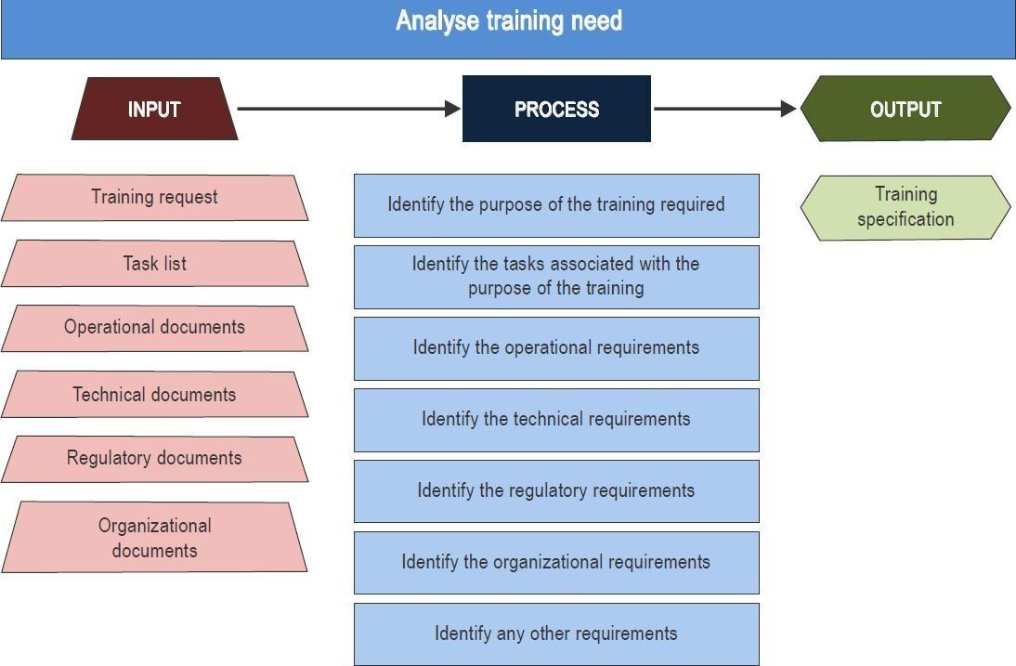

Phase 2 — Design competency-based training and assessment
        - Designing competency-based training and assessment is the second phase in the development and implementation of a competency-based training and assessment programme. This is achieved by utilizing the training specifications identified in Phase 1 and will include:
          - Designing an adapted competency model based on the training specification identified in Phase 1;
          - Designing an assessment plan that will be used to assess the competence of trainees; and
          - Designing a training plan that will enable the development and delivery of the training course.

    - Designing the adapted competency model
      - The competency model for dangerous goods should be adapted from the generic competency framework provided in this document. This generic framework provides a set of competencies that are typically needed to perform the dangerous goods tasks identified in the task list provided in this document.
      - The vast majority of adapted competency models will contain similar lists of competencies, but there may be a need to add or remove a competency depending on the employers own operational and organizational environments.
      - The generic framework also provides a comprehensive list of observable behaviors associated with each of the competencies.

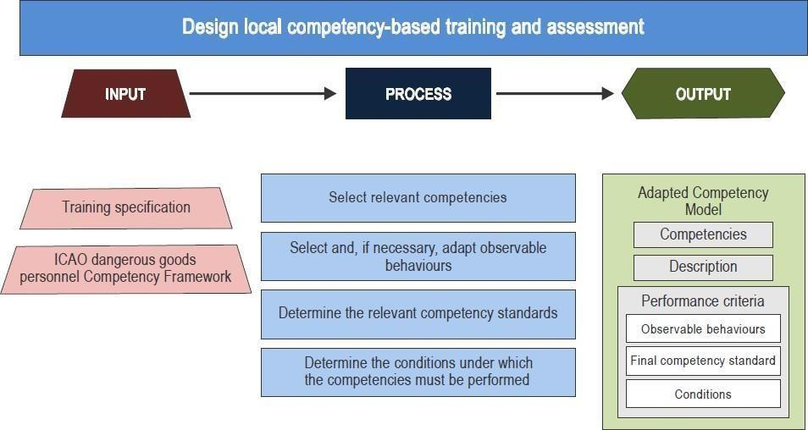
Phase 2 – Part 1

    - Designing an assessment plan

      - The purpose of the assessment plan is to detail how competence is going to be determined. The assessment plan details:
        - the final competency standard associated with the final milestone;
        - the interim competency standard associated with each milestone (if required);
        - the list of assessments (formative and summative assessments, examinations, oral assessments, etc.) required for each of the milestone(s) that have been defined;
        - when assessments should take place;
        - the tools to be used to collect evidence during practical assessment;
        - the pass marks for projects, examinations or oral assessments;
        - if required, the minimum number of formative assessments to be undertaken prior to starting summative assessments; and
        - the number of observations required to assess performance for the interim and final competency standards.
      - Additional administrative procedures may be necessary in the implementation of the assessment plan in relation to:
        - who is authorized to perform a specific task or assessment;
        - roles and responsibilities of personnel during conduct of assessments;
        - assessment procedures (preparation, conduct and post-assessment);
        - record- keeping,
        - actions to be taken if a trainee fails a competency assessment, etc. those procedures shall be documented in the training manual subject to review and approval by TCAA.

    - Competency-based training requires assessment of the trainees’ progress until they are competent to perform their assigned function. A trainee’s assessment may be completed using a variety of tools including observation of job performance, tests or other practical exercises.

    - In order for assessment tools to be effective, they must be valid and reliable both in terms of being an appropriate measure of the competency being assessed and of obtaining consistent results when administered by different assessors.

    - The assessment of personnel can be accomplished in a variety of ways. Some common examples to accomplish an assessment would be to utilize a written test, online test, oral test, observed practical exercises, online practical exercises and observation of on-the-job performance by fully trained personnel, i.e. designated OJT assessor. An employer might choose to utilize one assessment method or a combination of assessment methods, as long as the assessment confirms that the personnel have acquired the necessary competencies to perform the assigned functions.

    - The employer therefore establishes the assessment plan with all the specific details that would need to be accomplished to determine whether competence has been achieved by the trainee.

    - Employers electing to send personnel to third-party training providers also need to establish an assessment plan for ensuring that competence has been achieved by the trainee. The employer may incorporate the third-party provider’s assessment into its established assessment plan.

    - Even if the employer does not deliver any of the training itself, it can still choose to assess the trainees in the workplace to ensure they can perform their assigned tasks competently and incorporate that process into the assessment plan.

    - Designing a training plan
The training plan is to detail:
        - the composition and structure of the course;
        - the syllabus;
        - milestones (if required) see figure below;
        - modules, training events and their delivery sequence; and
        - the course schedule.

    - Training delivery method
The training delivery method must be defined and the common types include;
        - physical classroom;
        - virtual classroom;
        - e-learning;
        - simulation; and
        - On the job training.

    - Additional requirements for on-the-job training assessment
Initial training prescribed in the Civil Aviation (Air Operator Certification and Administration) Regulations shall be carried out before a candidate is allowed to undertake “on the Job training”.
        - OJT is required upon successful completion of initial and or refresher training.
        - The OJT record shall be signed by both the supervisor and trainee.
        - On successful completion of dangerous goods training, the trainee shall be required to complete an OJT commensurate with their responsibilities under direct supervision
        - The minimum period for OJT practical assessments shall be defined in the training programme

    - The training plan will be used by the training designer(s) to create the training and assessment materials.

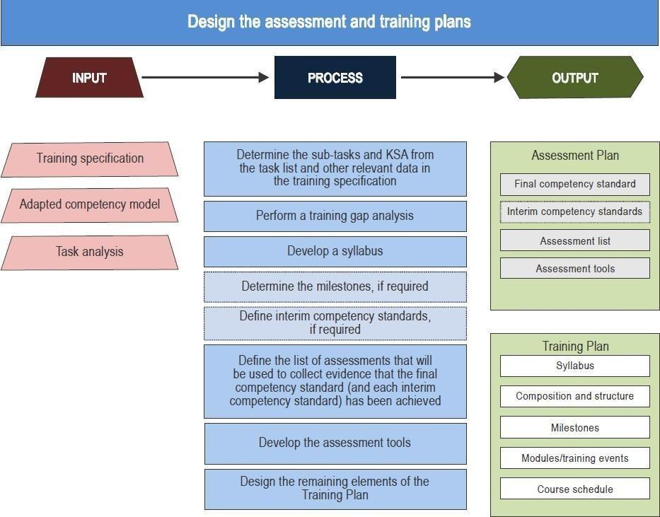
Phase 2 – Part 2
    - Relationship between the adapted competency model and the assessment and training plans
      - The training specification developed in Phase 1 serves as the common basis for the development of the adapted competency model and the training and assessment plans. The task list is generally used to aid the selection of the observable behaviours from the generic competency framework provided in this document. The operational, technical, regulatory and organizational requirements aid the development of the conditions and standards that will apply to the competencies and observable behaviours.
      - The same task list and requirements are used to develop the training plan. The training plan is used to prepare the trainees to undertake assessment to determine if they are competent in accordance with the adapted competency model. The adapted competency model and the training plan are used to develop the assessment plan.
      - The syllabus in the training plan is composed of training objectives derived from tasks and sub-tasks as well as the underlying knowledge, skills and attitudes necessary to perform them. The knowledge, skills and attitudes are determined on the basis of the task list in conjunction with operational, technical, regulatory and organizational requirements.
      - The employer should indicate what knowledge is needed for a particular task within the organization. The level of knowledge and/or skills necessary will differ depending on the task.
      - When assessing whether competence has been achieved, the adapted competency model, not the syllabus, is referenced. Consequently, the performance criteria are used to assess if competence has been achieved, and the tasks/sub- tasks that are carried out by the trainee are utilized to conduct the assessment.

    - Phase 3 — Develop the training and assessment materials
(a) The third phase in the development and implementation of a competency-based training and assessment programme is the development of the training and assessment materials. Development is based on the adapted competency model and the training and assessment plans. Training and assessment materials include but are not limited to training notes, exercise briefings, practical exercises, case studies, presentations, video clips, self-test quizzes, examinations, assessments and assessment tools.
(b) For each specific job function the employer shall establish the training materials in accordance with the Job Function task lists chosen.
(c) Checklists to be used for OJT assessments must also be developed at this phase

Phase 3
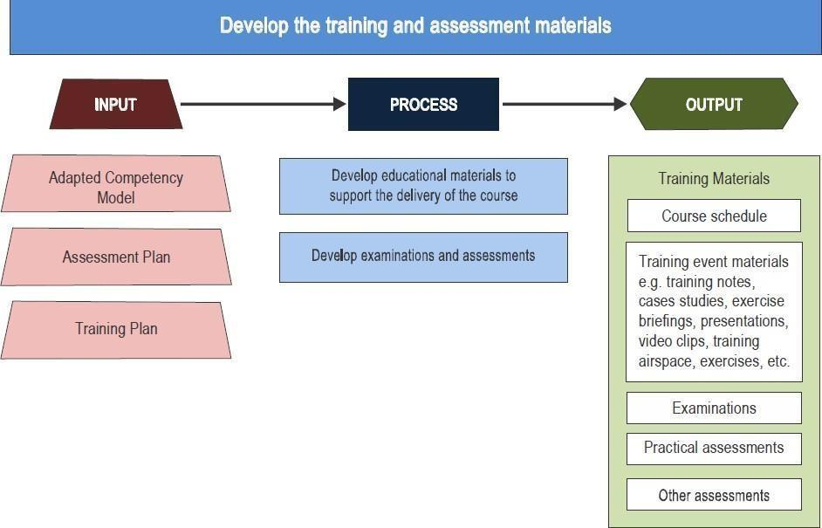
    - Conduct the course

      - Phase 4 — Conduct the course in accordance with the training and assessment plans The fourth phase in the development and implementation of a competency-based training and assessment programme is conducting the course in accordance with the training and assessment plans. This involves delivering the training; monitoring the progress of the trainees; providing timely and continuous feedback on their performance; diagnosing deficiencies in the training and addressing them in a timely manner; and carrying out assessments according to the assessment plan. The goal of this phase is a competent employee.

Phase 4
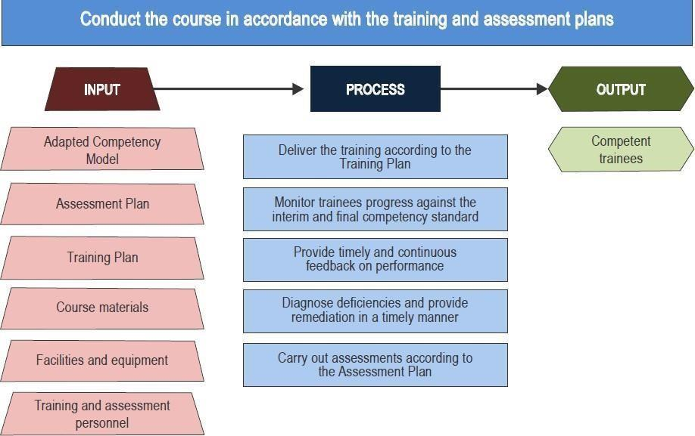

    - The approval of the competency-based training approach is subject to inspection and approval by t the TCAA inspectors to verify:
      - The full documentation of the first 3 Phases submitted and approved- this includes amended Training Programmes and Training Material.
      - The implementation of Phase 4 in line with the approved programme.
      - The compliance and the implementation of tools elaborated, submitted and approved during Phases 1, 2 and 3;
      - The assessment of the qualification and skills of the instructor when conducting the training using the CBTA approach

    - The audit will follow the normal TCAA audit process which involves issuance of findings where there are non-compliances. A corrective action plan must be submitted which clearly states how the deficiencies will be rectified and they will be prevented from happening again.

Approval Letter

    - Following the initial audit of the training programs using the CBTA Approach, TCAA will grant an approval if the training programs meet the requirements. The certificate will be amended to specify the CBTA approval in accordance with the documentation submitted (function granted, validity, transition period.)

    - Phase 5 — Evaluate The Course Including the Training and Assessment Plans
      - The employer is responsible for ensuring the effectiveness of the training programme. At the end of a period of training, feedback on performance on the job from trainees, instructors, assessors and employers should be gathered to determine the effectiveness of the training and assessment in supporting the progression of learning towards competence in the workplace.
      - Evaluation of the training should be based on valid and reliable evidence such as course results, trainee feedback, instructor feedback, audit reports, and occurrence reports. This evaluation may lead to changes or improvements being made to the competency-based training and assessment design.

PHASE 5

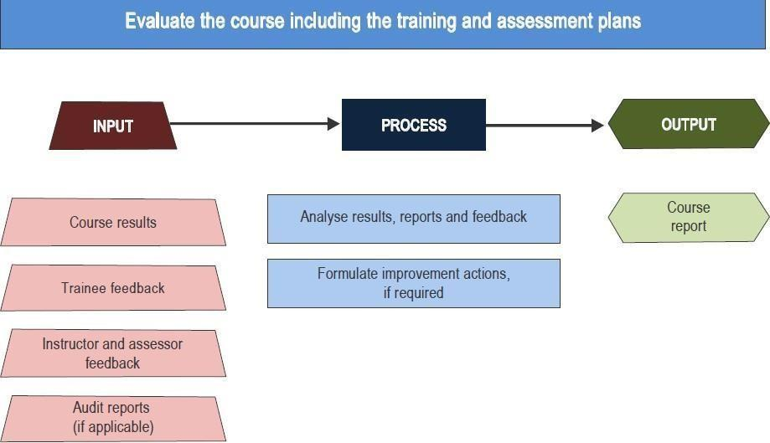

    - The monitoring of the CBTA approval by the TCAA may include the following:
      - Evaluation of the phase 5 submitted to the TCAA
      - Evaluation of the occurrence, previous reports, interviews of the staff, meetings; c. Internal/external audits reports;
      - An evaluation and assessment of the training programs performed by other training provider approved to use the CBTA approach; and
      - Assessment of the implementation for the approved course evaluation procedure.

Generic Dangerous Goods Task List

    - This chapter contains a generic list of tasks typically performed by dangerous goods personnel. The employer should adapt this task list to reflect the specific tasks performed by its personnel.

_______________________
Director Safety Regulation
Table 4-0. Generic Dangerous Goods Task List Template

TABLE 4.1.A

Sample Task List for Personnel Responsible for Preparing Dangerous Goods Consignments

Function: Personnel preparing dangerous goods consignments for transport (Personnel classifying dangerous goods for transport is provided simultaneously) |  |  |  | Classifying dangerous goods | Preparing dangerous goods shipment
0 | Understanding the basics of dangerous goods |  |  | *  * | *  *
 | 0.1 | Dangerous goods applicability |  |  | *
 |  | 0.1.1 | Understand the definition | * | *
 |  | 0.1.2 | Recognize the legal framework (global, national) | * | *
 |  | 0.1.3 | Identify the application scope | * | *
 |  | 0.1.4 | Differentiate hazard and risk | *  * | *
 | 0.2 | Understanding the general limitations |  | * | *
 |  | 0.2.1 | Develop a sense of forbidden dangerous goods | * | *
 |  | 0.2.2 | Recognize potential hidden dangerous goods | * | *
 |  | 0.2.3 | Familiarize with passenger provisions | * | *
 | 0.3 | Identifying roles and responsibilities
 |  | 0.3.1 | Clarify the individual and collective role of the supply chain stakeholders | *  * | *  *
 |  | 0.3.3 | Recognise the impact of State & operator variations | * | *
 | 0.4 | Understanding the importance of classification and packaging |  | * | *
 |  | 0.4.1 | Identify the general information about classes, divisions | * | *
 |  | 0.4.2 | Understand general principles of packing groups | * | *
 |  | 0.4.3 | Consider multiple hazards | * | *
 | 0.5 | Understanding hazard communication |  | * | *
 |  | 0.5.1 | Recognise the basic marking requirements | * | *
 |  | 0.5.2 | Recognise the basic labelling and requirements | * | *
 |  | 0.5.3 | Identify the required documentation | * | *
 | 0.6 | Familiarising with basic emergency response |  | * | *
 |  | 0.6.1 | Create awareness about general emergency procedures
 |  | 0.6.2 | Understand the employer's emergency response require- ments | * | *
1 | Classifying dangerous goods |  |  |  | **
 | 1.1 | Evaluate a substance or an article against the classification criteria |  | ***  ***
 |  | 1.1.1 | Determine if it is dangerous goods | *** | **
 |  | 1.1.2 | Determine if it is forbidden under any circumstances | *** | **  **
 | 1.2 | Determine dangerous goods description |  | *** | **
 |  | 1.2.1 | Determine class or division | *** | **
 |  | 1.2.2 | Determine packing group | *** | **
 |  | 1.2.3 | Determine proper shipping name and UN number
 |  | 1.2.4 | Determine if it is forbidden unless approval or exemption is granted | ***  *** | **  **
 | 1.3 | Review special provisions |  | *** | **
 |  | 1.3.1 | Assess if special provision(s) is applicable | *** | **
 |  | 1.3.2 | Apply special provision(s)
2 | Preparing dangerous goods shipment |  |  |  | ***
 | 2.1 | Assess packing options including quantity limitations
 |  | 2.1.1 | Consider limitations (de minimis quantities, excepted quan- tities, limited quantities, passenger aircraft, cargo aircraft only, special provisions, dangerous goods in the mail) |  | ***  ***
 |  | 2.1.2 | Consider State and operator variations
 |  | 2.1.3 | Determine if all-packed-in-one can be used |  | ***
 |  | 2.1.4 | Select how dangerous goods will be shipped based on limitations and variations |  | ***
 | 2.2 | Apply packing requirements |  |  | ***  ***
 |  | 2.2.1 | Consider constraints of packing instructions | ***
 |  | 2.2.2 | Identify and follow the instructions provided by the packag- ing manufacturer when UN specification packaging is used |  | ***
 |  | 2.2.3 | Select appropriate packaging materials (absorbent, cushioning, etc.) |  | ***  ***
 |  | 2.2.4 | Assemble package |  | ***
 | 2.3 | Apply marks and labels |  |  | ***
 |  | 2.3.1 | Determine applicable marks |  | ***
 |  | 2.3.2 | Apply marks |  | ***
 |  | 2.3.3 | Determine applicable labels |  | ***
 |  | 2.3.4 | Apply labels |  | ***
 | 2.4 | Assess use of overpack |  |  | ***
 |  | 2.4.1 | Determine if overpack can be used |  | ***
 |  | 2.4.2 | Apply marks if necessary |  | ***
 |  | 2.4.3 | Apply labels if necessary |  | ***
 | 2.5 | Prepare documentation |  |  | ***
 |  | 2.5.1 | Complete the Shipper's Declaration |  | ***
 |  | 2.5.2 | Complete other transport documents (e.g. air waybill)
 |  | 2.5.3 | Include other required documentation (approvals/exemptions, etc.) |  | ***  ***
 |  | 2.5.4 | Retain copies of documents

TABLE 4.2.A
Sample Task List for Personnel Responsible for Processing or Accepting Goods Presented asGeneral Cargo

Function: Personnel responsible for processing or accepting goods presented as general cargo |  |  |  | Processing/accepting cargo
0 | Understanding the basics of dangerous goods |  |  | *  *
 | 0.1 | Dangerous goods applicability |  | *
 |  | 0.1.1 | Understand the definition | *
 |  | 0.1.2 | Recognise the legal framework (global, national) | *
 |  | 0.1.3 | Identify the application and scope | *
 |  | 0.1.4 | Differentiate hazard and risk | *
 | 0.2 | Understanding the general limitations |  | *
 |  | 0.2.1 | Develop a sense of forbidden dangerous goods | *
 |  | 0.2.2 | Recognise potential hidden dangerous goods | *
 |  | 0.2.3 | Familiarise with passenger provisions | *
 | 0.3 | Identifying different roles and responsibilities
 |  | 0.3.1 | Clarify the individual and collective role of the supply chain stake- holders | *  *
 |  | 0.3.3 | Recognise the impact of State & operator variations | *
 | 0.4 | Understanding the importance of classification & packaging |  | *
 |  | 0.4.1 | Identify the general information about classes, divisions | *
 |  | 0.4.2 | Understand general principles of packing groups | *
 |  | 0.4.3 | Consider multiple hazards | *
 | 0.5 | Understanding hazard communication |  | *
 |  | 0.5.1 | Recognise the basic marking requirements | *
 |  | 0.5.2 | Recognise the basic labelling requirements | *
 |  | 0.5.3 | Identify the required documentation | *
 | 0.6 | Familiarising with emergency response |  | *
 |  | 0.6.1 | Create awareness about general emergency procedures | *
 |  | 0.6.2 | Understand the employer's emergency response requirements
3 | Processing/accepting cargo |  |  | ***
 | 3.4 | Process/accept cargo other than dangerous goods
 |  | 3.4.1 | Check documentation for indications of hidden/undeclared dangerous goods | ***
 |  | 3.4.2 | Check packages for indications of hidden/undeclared dangerous goods | ***
7 | Collecting safety data |  |  | **
 | 7.1 | Report dangerous goods accidents |  | **
 | 7.2 | Report dangerous goods incidents |  | **
 | 7.3 | Report undeclared/mis-declared dangerous goods |  | **
 | 7.4 | Report dangerous goods occurrences

TABLE 4.3.A
Sample Task List for Personnel Responsible for Processing or Accepting Dangerous Goods Consignments

Function: Personnel responsible for processing or accepting dangerous goods consignments |  |  |  | Processing/accepting cargo
0 | Understanding the basics of dangerous goods |  |  | *  *
0 | 0.1 | Dangerous goods applicability |  | *
0 | 0.1 | 0.1.1 | Understand the definition | *
0 | 0.1 | 0.1.2 | Recognize the legal framework (global, national) | *
0 | 0.1 | 0.1.3 | Identify the application and scope | *
0 | 0.1 | 0.1.4 | Differentiate between hazard and risk | *
0 | 0.2 | Understanding the general limitations |  | *
0 | 0.2 | 0.2.1 | Develop a sense of forbidden dangerous goods | *
0 | 0.2 | 0.2.2 | Recognise potential hidden dangerous goods | *
0 | 0.2 | 0.2.3 | Familiarised with passenger provisions | *
0 | 0.3 | Identifying different roles and responsibilities
0 | 0.3 | 0.3.1 | Clarify the individual and collective role of the supply chain stake- holders | *  *
0 | 0.3 | 0.3.3 | Recognise the impact of State & operator variations | *
0 | 0.4 | Understanding the importance of classification & packaging |  | *
0 | 0.4 | 0.4.1 | Identify the general information about classes, divisions | *
0 | 0.4 | 0.4.2 | Understand general principles of packing groups | *
0 | 0.4 | 0.4.3 | Consider multiple hazards | *
0 | 0.5 | Understanding hazard communication |  | *
0 | 0.5 | 0.5.1 | Recognise the basic marking requirements | *
0 | 0.5 | 0.5.2 | Recognize the basic labelling requirements | *
0 | 0.5 | 0.5.3 | Identify the required documentation | *
0 | 0.6 | Familiarising with basic emergency response |  | *
0 | 0.6 | 0.6.1 | Create awareness about general emergency procedures | *
0 | 0.6 | 0.6.2 | Understand the employer's emergency response requirements
3 | Processing/accepting cargo |  |  | ***
3 | 3.1 | Review documentation |  | ***
3 | 3.1 | 3.1.1 | Verify Shipper's Declaration | ***
3 | 3.1 | 3.1.2 | Verify other transport documents (e.g. air waybill) | ***
3 | 3.1 | 3.1.3 | Verify other documents (exemptions, approvals, etc.) | ***
3 | 3.1 | 3.1.4 | Verify State/operator variations | ***
3 | 3.2 | Review package(s) |  | ***
3 | 3.2 | 3.2.1 | Verify marks | ***
3 | 3.2 | 3.2.2 | Verify labels | ***
3 | 3.2 | 3.2.3 | Verify packaging type | ***
3 | 3.2 | 3.2.4 | Verify package conditions | ***
3 | 3.2 | 3.2.5 | Verify State/operator variations | ***
3 | 3.3 | Complete acceptance procedures |  | ***
3 | 3.3 | 3.3.1 | Complete acceptance checklist | ***
3 | 3.3 | 3.3.2 | Provide shipment information for load planning | ***
3 | 3.3 | 3.3.3 | Retain documents
7 | Collecting safety data |  |  | **
7 | 7.1 | Report dangerous goods accidents |  | **
7 | 7.2 | Report dangerous goods incidents |  | **
7 | 7.3 | Report undeclared/mis-declared dangerous goods |  | **
7 | 7.4 | Report dangerous goods occurrences

TABLE 4.4.A
Sample Task List for Personnel Responsible for Handling in a Warehouse, Loading and UnloadingUnit Load Devices and Loading and Unloading Aircraft Cargo Compartments

Function: Personnel responsible for handling cargo in a warehouse, loading and unloading ULD and loading and unloading aircraft cargo compartments. |  |  |  | Managing cargo pre-loading
0 | Understanding the basics of dangerous goods |  |  | *  *
 | 0.1 | Dangerous goods applicability |  | *
 |  | 0.1.1 | Understand the definition | *
 |  | 0.1.2 | Recognize the legal framework (global, national) | *
 |  | 0.1.3 | Identify the application and scope | *
 |  | 0.1.4 | Differentiate hazard and risk | *
 | 0.2 | Understanding the general limitations |  | *
 |  | 0.2.1 | Develop a sense of hidden dangerous goods | *
 |  | 0.2.2 | Recognise potential hidden dangerous goods | *
 |  | 0.2.3 | Familiarise with passenger provisions | *
 | 0.3 | Identifying roles and responsibilities
 |  | 0.3.1 | Clarify the individual and collective role of the supply chain stake- holders | *  *
 |  | 0.3.2 | Recognise the impact of State & operator variations | *
 | 0.4 | Understanding the importance of classification & packaging |  | *
 |  | 0.4.1 | Identify the general information about classes, divisions | *
 |  | 0.4.2 | Understand general principles of packing groups | *
 |  | 0.4.3 | Consider multiple hazards | *
 | 0.5 | Understanding hazard communication |  | *
 |  | 0.5.1 | Recognise the basic marking requirements | *
 |  | 0.5.2 | Recognise the basic labelling requirements | *
 | 0.6 | Familiarising with basic emergency response |  | *
 |  | 0.6.1 | Create awareness about general emergency procedures | *
 |  | 0.6.2 | Under the employer's emergency response requirements
4 | Managing cargo pre-loading |  |  | ***
 | 4.1 | Plan the load |  | ***
 |  | 4.1.1 | Determine stowage requirements | ***
 |  | 4.1.2 | Determine segregation, separation, cargo compartment limitations | ***
 | 4.2 | Prepare load for aircraft
 |  | 4.2.1 | Check packages for indications of hidden/undeclared dangerous goods | ***  ***
 |  | 4.2.2 | Check for damage and/or leakage
 |  | 4.2.3 | Apply stowage requirements (i.e. segregation, separation, orientation, securing and protecting from damage) | ***  ***
 |  | 4.2.4 | Apply ULD tags when applicable | ***
 |  | 4.2.5 | Transport cargo to aircraft
6 | Transporting cargo/baggage |  |  | ***
 | 6.1 | Load aircraft |  | ***
 |  | 6.1.1 | Transport cargo/baggage to aircraft
 |  | 6.1.2 | Check packages for indications of hidden/undeclared dangerous goods | ***  ***
 |  | 6.1.3 | Check for damage and/or leakage
 |  | 6.1.4 | Apply stowage requirements (i.e. segregation, separation, orientation, securing and protecting from damage) | ***  ***
 |  | 6.1.5 | Verify aircraft load against NOTOC
 |  | 6.1.6 | Provide NOTOC information to pilot-in-command and flight operations officer/flight dispatcher | ***  ***
 | 6.3 | Unload aircraft |  | ***
 |  | 6.3.1 | Apply specific unloading considerations
 |  | 6.3.2 | Check packages for indications of hidden/undeclared dangerous goods | ***  ***
 |  | 6.3.3 | Check for damage and/or leakage
 |  | 6.3.4 | Transport cargo/baggage to facility/terminal | ***
7 | Collecting safety data |  |  | **
 | 7.1 | Report dangerous goods accidents |  | **
 | 7.2 | Report dangerous goods incidents |  | **
 | 7.3 | Report undeclared/mis-declared dangerous goods |  | **
 | 7.4 | Report dangerous goods occurrences

TABLE 4.5.A
Sample Task List for Personnel Responsible for Accepting Passenger and Crew Baggage, ManagingAircraft Boarding Areas and other Functions Involving Direct Passenger Contact at an Airport

Function: Personnel responsible for accepting passenger and crew baggage, managing aircraft boarding areas and other functions involving direct passenger contact at an airport. |  |  |  | Accepting passenger and crew baggage
0 | Understanding the basics of dangerous goods |  |  | *  *
 | 0.1 | Dangerous goods applicability |  | *
 |  | 0.1.1 | Understand the definition | *
 |  | 0.1.2 | Recognise the legal framework (global, national) | *
 |  | 0.1.3 | Identify the application and scope | *
 |  | 0.1.4 | Differentiate hazard and risk | *
 | 0.2 | Understanding the general limitations |  | *
 |  | 0.2.1 | Develop a sense of hidden dangerous goods | *
 |  | 0.2.2 | Recognise potential hidden dangerous goods | *
 |  | 0.2.3 | Familiarise with passenger provisions | *
 | 0.3 | Identifying roles and responsibilities
 |  | 0.3.1 | Clarify the individual and collective role of the supply chain stake- holders | *  *
 |  | 0.3.2 | Understand the passengers responsibilities | *
 |  | 0.3.3 | Recognise the impact of State & operator variations | *
 | 0.4 | Understanding the importance of classification & packaging |  | *
 |  | 0.4.1 | Identify the general information about classes, divisions | *
 | 0.5 | Understanding hazard communication |  | *
 |  | 0.5.1 | Recognise basic marking requirements | *
 |  | 0.5.2 | Recognise basic labelling requirements | *
 |  | 0.5.3 | Identify the required documentation | *
 | 0.6 | Familiarising with basic emergency response |  | *
 |  | 0.6.1 | Create awareness about general emergency procedures | *
 |  | 0.6.2 | Understand the employer's emergency response requirements
5 | Accepting passenger and crew baggage |  |  | ***
 | 5.1 | Process baggage |  | ***
 |  | 5.1.1 | Identify forbidden dangerous goods | ***
 |  | 5.1.2 | Apply approval requirements | ***
 | 5.2 | Accept baggage |  | ***
 |  | 5.2.1 | Apply operator requirements | ***
 |  | 5.2.2 | Verify passenger baggage requirements | ***
 |  | 5.2.3 | Advise pilot-in-command, when applicable
7 | Collecting safety data |  |  | *
 | 7.1 | Report dangerous goods accidents |  | *
 | 7.2 | Report dangerous goods incidents |  | *
 | 7.3 | Report undeclared/mis-declared dangerous goods |  | *
 | 7.4 | Report dangerous goods occurrences

TABLE 4.6.A
Sample Task List for Personnel Responsible for the Planning of Aircraft Loading

Function: Personnel responsible for the planning of aircraft loading. |  |  |  | Managing cargo pre-loading
0 | Understanding the basics of dangerous goods |  |  | *  *
 | 0.1 | Dangerous goods applicability |  | *
 |  | 0.1.1 | Understand the definition | *
 |  | 0.1.2 | Recognize the legal framework (global, national) | *
 |  | 0.1.3 | Identify the application and scope | *
 |  | 0.1.4 | Differentiate hazard and risk | *
 | 0.2 | Understanding the general limitations |  | *
 |  | 0.2.1 | Develop a sense of forbidden dangerous goods | *
 |  | 0.2.2 | Recognise potential hidden dangerous goods | *
 |  | 0.2.3 | Familiarise with passenger provisions | *
 | 0.3 | Identifying roles and responsibilities
 |  | 0.3.1 | Clarify the individual and collective role of the supply chain stake- holders | *  *
 |  | 0.3.2 | Understand the passenger's responsibilities | *
 |  | 0.3.3 | Recognised the impact of State & operator variations | *
 | 0.4 | Understanding the importance of classification & packaging |  | *
 |  | 0.4.1 | Identify the general information about classes, divisions | *
 |  | 0.4.2 | Understand general principles of packing groups | *
 |  | 0.4.3 | Consider multiple hazards | *
 | 0.5 | Understanding hazard communication |  | *
 |  | 0.5.1 | Recognise the basic marking requirements | *
 |  | 0.5.2 | Recognise the basic labelling requirements | *
 |  | 0.5.3 | Identify the required documentation | *
 | 0.6 | Familiarising with basic emergency response |  | *
 |  | 0.6.1 | Create awareness about general emergency procedures | *
 |  | 0.6.2 | Understand the employer's emergency response requirements
4 | Managing cargo pre-loading
 | 4.1 | Plan the load |  | ***
 |  | 4.1.1 | Determine stowage requirements | ***
 |  | 4.1.2 | Determine segregation, separation, compartment limitations | ***
 | 4.3 | Issue NOTOC |  | ***
 |  | 4.3.1 | Enter required information | ***
 |  | 4.3.2 | Verify conformance with load plan | ***
 |  | 4.3.3 | Transmit to loading personnel
6 | Transporting cargo/baggage
 | 6.1 | Load aircraft
 |  | 6.1.6 | Provide NOTOC information to pilot-in-command and flight operations officer/flight dispatcher | ***
7 | Collecting safety data |  |  | **
 | 7.1 | Report dangerous goods accidents |  | **
 | 7.2 | Report dangerous goods incidents |  | **
 | 7.3 | Report undeclared/mis-declared dangerous goods |  | **
 | 7.4 | Report dangerous goods occurrences

TABLE 4.7.A
Sample Task List for Flight Crew

Function: Flight Crew |  |  |  | Managing cargo pre-loading
0 | Understanding the basics of dangerous goods |  |  | *  *
 | 0.1 | Dangerous goods applicability |  | *
 |  | 0.1.1 | Understand the definition | *
 |  | 0.1.2 | Recognise the legal framework (global, national) | *
 |  | 0.1.3 | Identify the application scope | *
 |  | 0.1.4 | Differentiate hazard and risk | *
 | 0.2 | Understanding the general limitations |  | *
 |  | 0.2.1 | Develop a sense of forbidden dangerous goods | *
 |  | 0.2.2 | Recognise potential hidden dangerous goods | *
 |  | 0.2.3 | Familiarise with passenger provisions | *
 | 0.3 | Identifying roles and responsibilities
 |  | 0.3.1 | Clarify the individual and collective role of the supply chain stake- holders | *  *
 |  | 0.3.2 | Understand the passenger's responsibilities | *
 |  | 0.3.3 | Recognise the impact of State & operator variations | *
 | 0.4 | Understanding the importance of classification & packaging |  | *
 |  | 0.4.1 | Identify the general information about classes, divisions | *
 |  | 0.4.2 | Understand general principles of packing groups | *
 |  | 0.4.3 | Consider multiple hazards | *
 | 0.5 | Understanding hazard communication |  | *
 |  | 0.5.1 | Recognise the basic marking requirements | *
 |  | 0.5.2 | Recognise the basic labelling requirements | *
 |  | 0.5.3 | Identify the required documentation | *
 | 0.6 | Familiarising with basic emergency response |  | *
 |  | 0.6.1 | Create awareness about general emergency procedures | *
 |  | 0.6.2 | Understand the employer's emergency response requirements
6 | Transporting cargo/baggage |  |  | ***
 | 6.2 | Manage dangerous goods pre and during flight |  | ***
 |  | 6.2.1 | Address dangerous goods not permitted in baggage | ***
 |  | 6.2.2 | Interpret NOTOC | ***
 |  | 6.2.3 | Apply procedures in the event of an emergency
 |  | 6.2.4 | Inform flight operations officer/flight dispatcher/air traffic control in the event of an emergency | ***
 |  | 6.2.5 | Inform emergency services of the dangerous goods on the NOTOC in the event of an emergency | ***
7 | Collecting safety data |  |  | **
 | 7.1 | Report dangerous goods accidents |  | **
 | 7.2 | Report dangerous goods incidents |  | **
 | 7.3 | Report undeclared/mis-declared dangerous goods |  | **
 | 7.4 | Report dangerous goods occurrences

TABLE 4.8.A
Sample Task List for Flight Operations Officers and Flight Dispatchers

Function: Personnel responsible for flight operations and flight dispatchers |  |  |  | Managing cargo pre-loading
0 | Understanding the basics of dangerous goods |  |  | *  *
 | 0.1 | Dangerous goods applicability |  | *
 |  | 0.1.1 | Understand the definition | *
 |  | 0.1.2 | Recognise the legal framework (global, national) | *
 |  | 0.1.3 | Identify the application and scope | *
 |  | 0.1.4 | Differentiate hazard and risk | *
 | 0.2 | Understanding the general limitations |  | *
 |  | 0.2.1 | Develop a sense of forbidden dangerous goods | *
 |  | 0.2.2 | Recognise potential hidden undeclared dangerous goods | *
 |  | 0.2.3 | Familiarise with passenger provisions | *
 | 0.3 | Identifying roles and responsibilities
 |  | 0.3.1 | Clarify the individual and collective role of the supply chain stake- holders | *  *
 |  | 0.3.2 | Understand the passengers responsibilities | *
 |  | 0.3.3 | Recognise the impact of State & operator variations | *
 | 0.4 | Understanding the importance of classification & packaging |  | *
 |  | 0.4.1 | Identify the general information about classes, divisions | *
 |  | 0.4.2 | Understand general principles of packing groups | *
 |  | 0.4.3 | Consider multiple hazards | *
 | 0.5 | Understanding hazard communication |  | *
 |  | 0.5.1 | Recognise the basic marking requirements | *
 |  | 0.5.2 | Recognise the basic labelling requirements | *
 |  | 0.5.3 | Identify the required documentation | *
 | 0.6 | Familiarising with basic emergency response |  | *
 |  | 0.6.1 | Create awareness about general emergency procedures | *
 |  | 0.6.2 | Understand the employer's emergency response requirements
6 | Transporting cargo/baggage
 | 6.2 | Manage dangerous goods pre and during flight |  | ***
 |  | 6.2.1 | Address dangerous goods not permitted in baggage | ***
 |  | 6.2.2 | Interpret NOTOC | ***
 |  | 6.2.3 | Apply procedures in the event of an emergency
 |  | 6.2.4 | Inform flight operations officer/flight dispatcher/air traffic control in the event of an emergency | ***
 |  | 6.2.5 | Inform emergency services of the dangerous goods on the NOTOC in the event of an emergency | ***

TABLE 4.9.A
Sample Task List for Cabin Crew

Function: Cabin Crew |  |  |  | Transporting cargo/ baggage
0 | Understanding the basics of dangerous goods |  |  | *  *
 | 0.1 | Dangerous goods applicability |  | *
 |  | 0.1.1 | Understand the definition | *
 |  | 0.1.2 | Recognise the legal framework (global, national) | *
 |  | 0.1.3 | Identify the application and scope | *
 |  | 0.1.4 | Differentiate hazard and risk | *
 | 0.2 | Understanding the general limitations |  | *
 |  | 0.2.1 | Develop a sense of forbidden dangerous goods | *
 |  | 0.2.2 | Recognise the potential hidden dangerous goods | *
 |  | 0.2.3 | Familiarise with passenger's provisions | *
 | 0.3 | Identifying roles and responsibilities
 |  | 0.3.1 | Clarify the individual and collective role of the supply chain stake- holders | *  *
 |  | 0.3.2 | Understand the passengers responsibilities | *
 |  | 0.3.3 | Recognise the impact of State & operatorP variations | *
 | 0.4 | Understanding the importance of classification & packaging |  | *
 |  | 0.4.1 | Identify the general information about classes, divisions | *
 | 0.5 | Understanding hazard communication |  | *
 |  | 0.5.1 | Recognise the basic marking requirements | *
 |  | 0.5.2 | Recognise the basic labelling requirements | *
 |  | 0.5.3 | Identify the required documentation for DG shipments | *
 | 0.6 | Familiarising with basic emergency response |  | *
 |  | 0.6.1 | Create awareness about general emergency procedures | *
 |  | 0.6.2 | Understand the employer's emergency response requirements
5 | Accepting passenger and crew baggage |  |  | ***
 | 5.2 | Accept baggage |  | ***
 |  | 5.2.1 | Apply operator requirements | ***
 |  | 5.2.2 | Verify passenger baggage requirements
6 | Transporting cargo/baggage |  |  | ***
 | 6.2 | Manage dangerous goods pre and during flight |  | ***
 |  | 6.2.1 | Address dangerous goods not permitted in baggage | ***
 |  | 6.2.3 | Apply procedures in the event of an emergency
7 | Collecting safety data |  |  | *
 | 7.1 | Report dangerous goods accidents |  | *
 | 7.2 | Report dangerous goods incidents |  | *
 | 7.3 | Report undeclared/mis-declared dangerous goods |  | *
 | 7.4 | Report dangerous goods occurrences

TABLE 4.10.A
Sample Task List for Personnel Responsible for the Screening of Passengers and Crew and their Baggage, Cargo and Mail

Function: Personnel responsible for security screening (Passengers and crew, baggage, cargo and mail) |  |  |  | Collecting safety data
0 | Understanding the basics of dangerous goods |  |  | *  *
 | 0.1 | Dangerous goods applicability |  | *
 |  | 0.1.1 | Understand the definition | *
 |  | 0.1.2 | Recognise the legal framework (global, national) | *
 |  | 0.1.3 | Identify the application and scope | *
 |  | 0.1.4 | Differentiate hazard and risk | *
 | 0.2 | Understanding the general limitations |  | *
 |  | 0.2.1 | Develop a sense of forbidden dangerous goods | *
 |  | 0.2.2 | Recognise potential hidden dangerous goods | *
 |  | 0.2.3 | Familiarise with passenger provisions | *
 | 0.3 | Identifying roles and responsibilities |  | *
 |  | 0.3.1 | Clarify the individual and collective role of the supply chain stakeholders | *
 |  | 0.3.2 | Understand the passenger's responsibilities | *
 |  | 0.3.3 | Recognise the impact of State & operator variations | *
 | 0.4 | Understanding the importance of classification & packaging |  | *
 |  | 0.4.1 | Identify the general information about classes, divisions | *
 | 0.5 | Understanding hazard communication |  | *
 |  | 0.5.1 | Recognise the basic marking requirements | *
 |  | 0.5.2 | Recognise the basic labeling requirements | *
 |  | 0.5.3 | Identify the required documentation | *
 | 0.6 | Familiarising with basic emergency response |  | *
 |  | 0.6.1 | Create awareness about general emergency procedures | *
 |  | 0.6.2 | Understand the employer's emergency response requirements
3 | Processing/accepting cargo |  |  | ***
 | 3.4 | Process/accept cargo other than dangerous goods
 |  | 3.4.1 | Check documentation for indications of hidden/undeclared dangerous goods | ***  ***
 |  | 3.4.2 | Check packages for indications of hidden/undeclared dangerous goods
5 | Accepting passenger and crew baggage |  |  | ***
 | 5.1 | Process baggage |  | ***
 |  | 5.1.1 | Identify forbidden dangerous goods | ***
 |  | 5.1.2 | Apply approval requirements
7 | Collecting safety data |  |  | *
 | 7.1 | Report dangerous goods accidents |  | *
 | 7.2 | Report dangerous goods incidents |  | *
 | 7.3 | Report undeclared/mis-declared dangerous goods

